**Group 10 Music Database Instruction Writeup**

Our project is a simple music database that uses NodeJS to connect to a MySQL database. It also uses HTML/CSS/Javascript for the UI.

In order to run this project you will need to follow these instructions:

**1.** Download, install and setup NodeJS on your machine

Link for Mac/Windows: **<https://nodejs.org/en/download/>**

**2.** Download, install and setup MySQL on your machine

Link for Mac: **<https://dev.mysql.com/downloads/mysql/>**

Link for Windows: **<https://dev.mysql.com/downloads/mysql/>**

**3.** Get a local copy of the code from our group’s repository

Github link: **<https://github.com/shayneptorres/SER322_my_music_library>**

***(Note that the GitHub repository also includes readme files for the SQL scripts)***

**4.** Run the following commands from the command prompt/terminal:

To install dependencies - ***npm install***

To build code - ***npm run build***

To run app (creates the database and all the tables) - ***npm run dev***

To seed the database - ***npm run seed***

To clear the database in the event of multiple seeds running - ***npm run clean-db***

***(Note that after running this the user will have to start at the very beginning and re run all of the commands)***

**5.** In your local web browser go to: **<http://localhost:3000/home>**

Note that it is important here to remember to have ran ***npm run dev.***Also make sure the app has not crashed.

If you have followed all of the instructions provided above then all should be working smoothly. Enjoy!

**Updated ER Diagram**

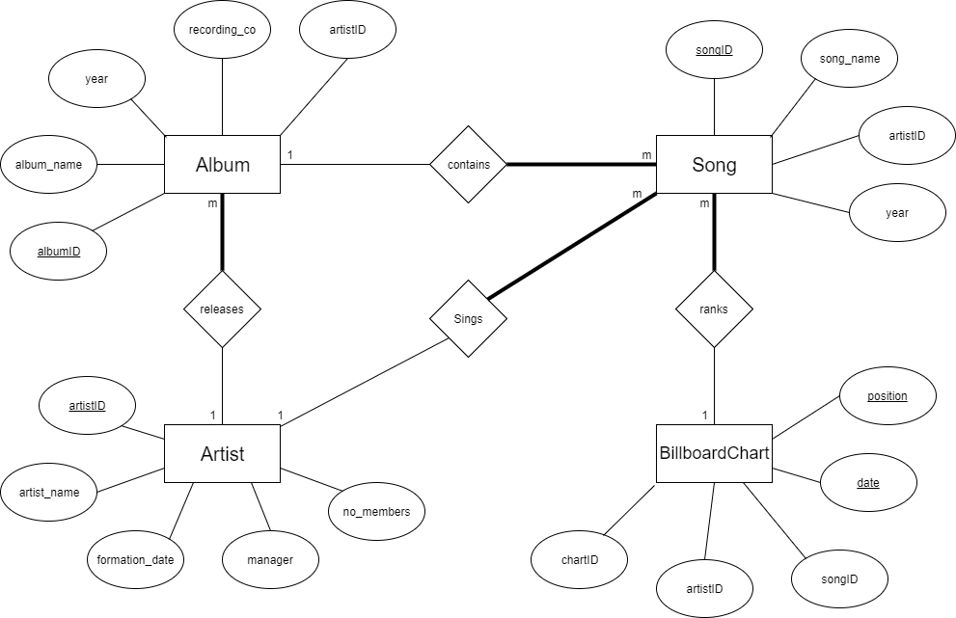

**Entities and their attributes:**

**Song:** songID, name, artistID, positionID, year

**Album:** albumID, name, artist, recordingCo, year

**Artist:** artistID, bandName, manager, formationDate

**Billboard Chart Position:** date, position, artistID, songID, albumID

**Relationships:**

**Contains:** an album contains songs

**Ranks:** songs rank on the billboard charts

**Sings:** artist sings songs

**Releases:** artist releases an album

**Assumptions:**

- Album can contain many songs, or no songs  
- Song must belong to one album  
- Artist can release many albums, or no albums  
- Albums must belong to one Artist  
- Artist can sing many songs, or no songs  
- Song must belong to an Artist  
- Billboard Chart Position can have many songs, or no songs  
- Artist can have more than one song ranked on the billboard chart  
- A songs can rank on one chart position, or no chart positions